Arcade Shooter Project

CS122A: Fall 2019

Winson Bi

Table of Contents

**Introduction** **3**

**Hardware** **6**

Parts List 6

**Adafruit IR Break Beam Sensor - 5mm LEDs** **6**

Block Diagram 8

Pinout (For each microcontroller/processor) 8

**Software** **9**

**Implementation Reflection** **10**

Milestone 11

Completed components 11

Incomplete components 12

**Youtube Links** **12**

**Testing** **12**

**Known Bugs** **13**

**Resume/Curriculum Vitae (CV) Blurb** **13**

**Future work** **14**

**References** **14**

**Appendix** **14**

# Introduction

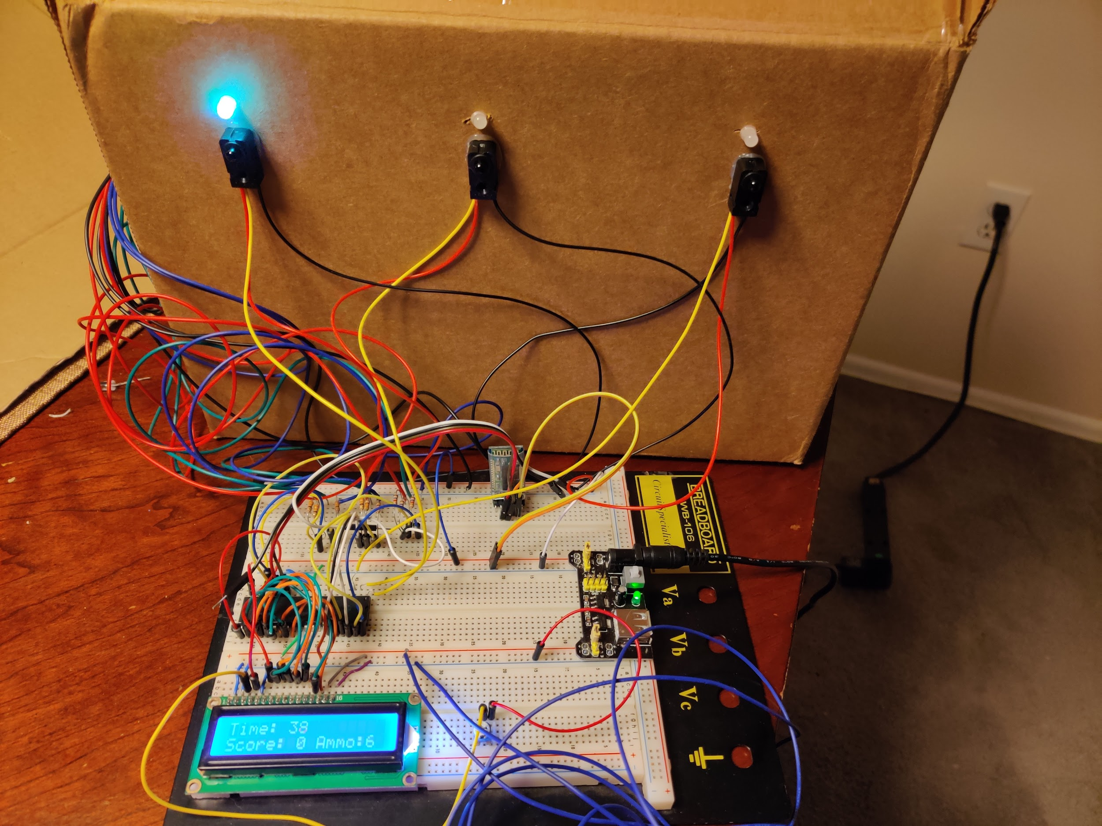

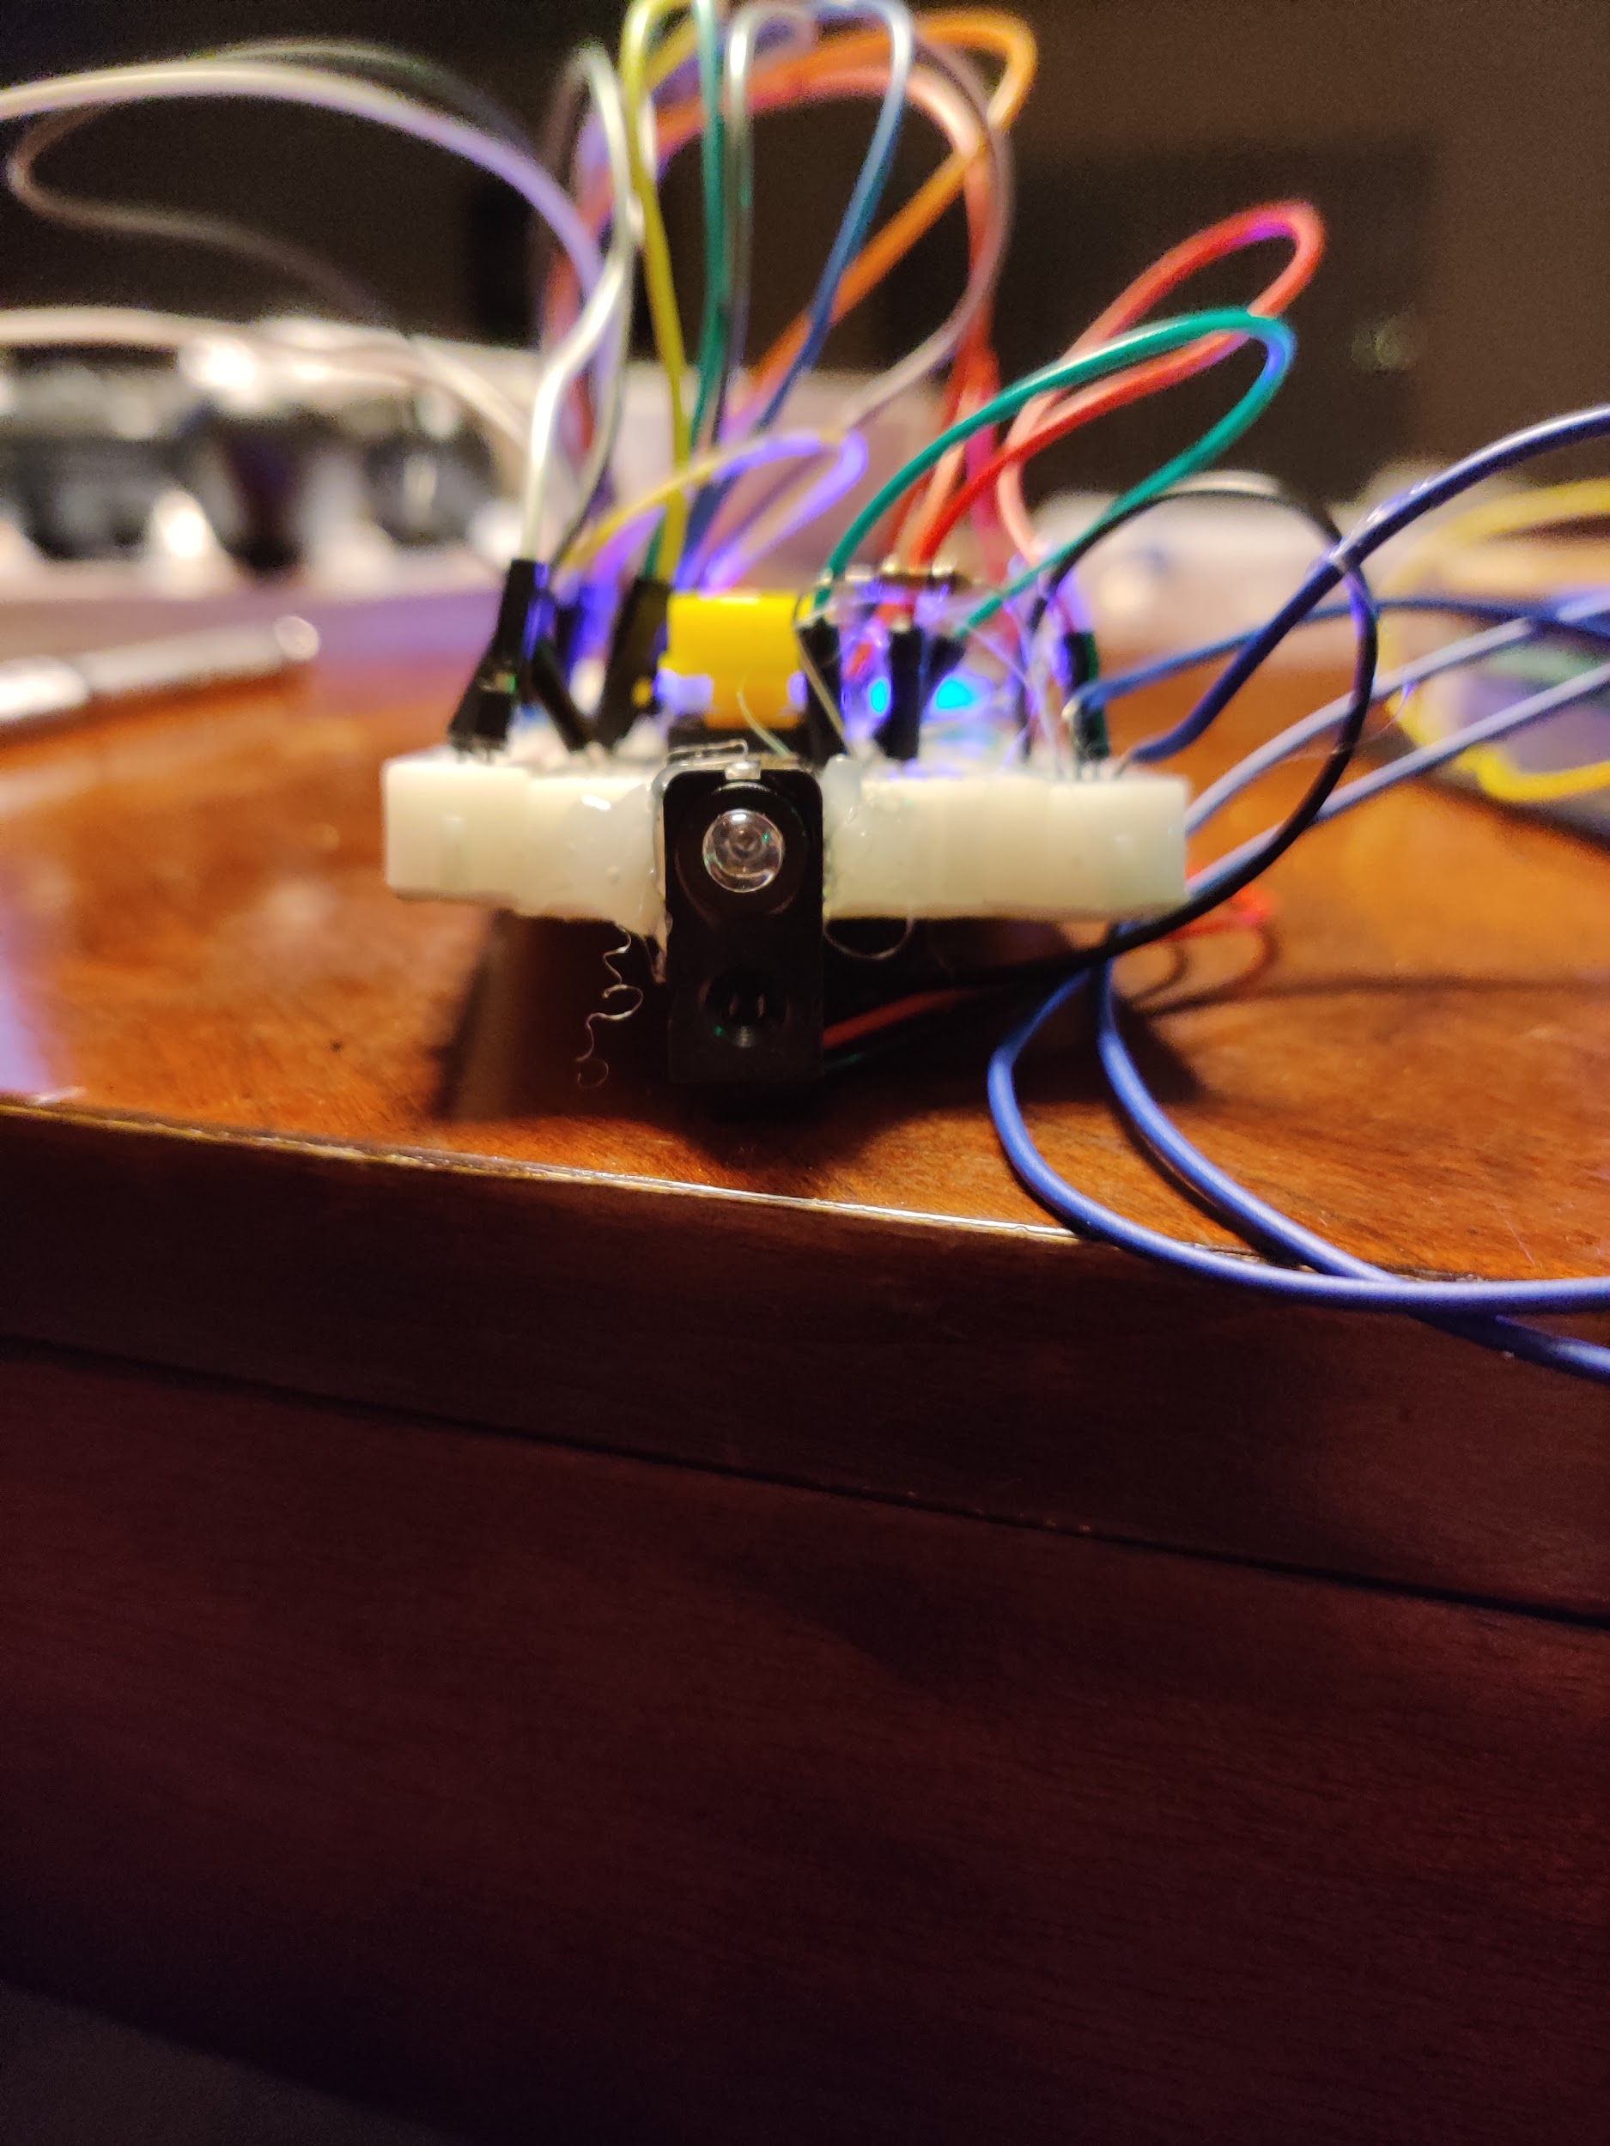

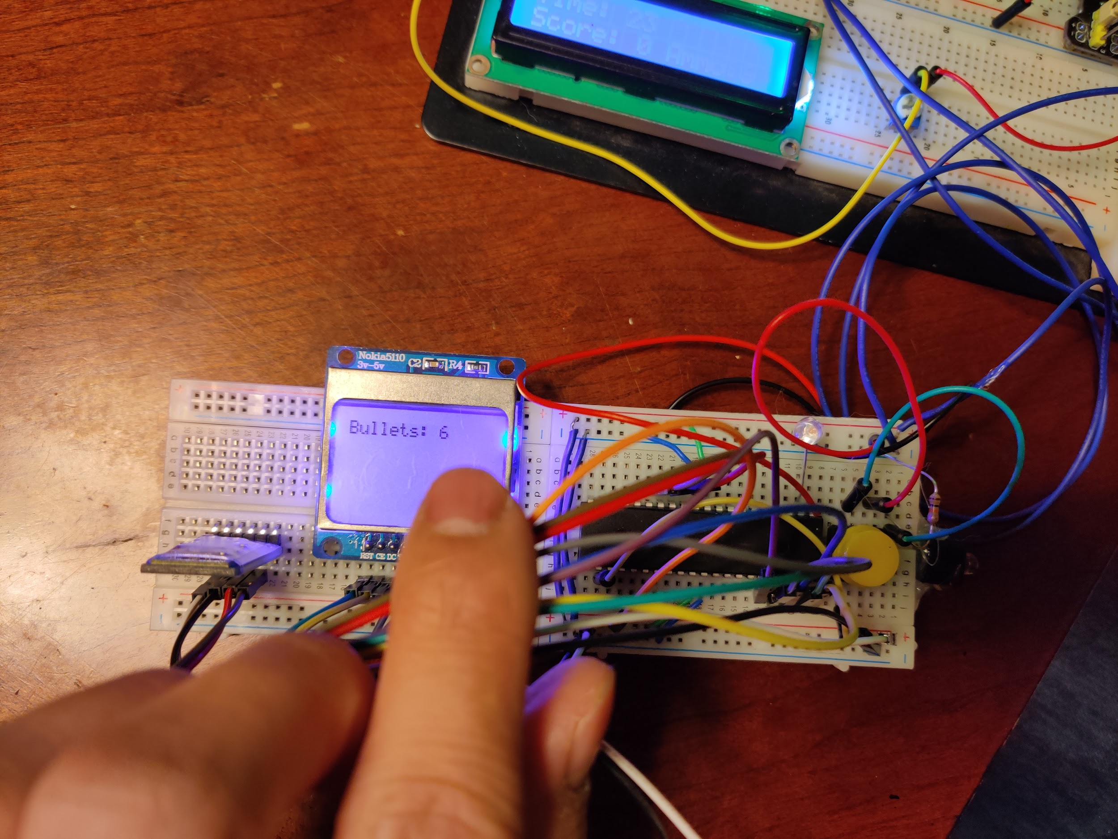

My CS122A final project is an arcade shooter where the player has a remote and shoots at a target board that lights up and has multiple targets. The targets move and if the shooters hit them they get one point. There are special targets in the game that are marked with a different color LED above the target. They appear periodically and if are shot will give an extra point along with three extra bullets for the player. The player can have a maximum of 6 bullets in their arcade gun.

My project is an arcade shooter implemented with two ATMega 1824 controllers. One ATMega 1284 is for the target board and one is for the gun that the player uses to shoot the target board. The target board the gun communicate via Universal Synchronous/Asynchronous Receiver/Transmitter Protocol using two HC-05 bluetooth modules. The targets on the target board are implemented using IR receivers while the gun uses an IR beam to trigger the IR receivers. The gun is shot using a button and displays the current bullets on an LCD screen.

The target board also has an LCD screen that shows the score, the guns current number of bullets, and the remaining time left.

# 

# 

# Hardware

## Parts List

| Part | Part # | Quantity | Price (optional) |
| --- | --- | --- | --- |
| ATMega1284 | ATMega1284 | 2 | 10 |
| **HC-05 Bluetooth Module** | CZ-HC-05 | 2 | 13 |
| **Adafruit IR Break Beam Sensor - 5mm LEDs** | ADA2168 | 3 | 33 |
| LED Pack | CO RODE RGB LED, 3mm 5mm LED Diode Light Kit with Color White Red Blue Green Yellow UV, Fast, Slow Flashing, RGB | 1 | 14 |
| Mini Bread Boards | HiLetgo 3pcs 400 Ties Mini Solderless Breadboard Universal 400 Contacts Solderless Breadboard 400 Points Prototyping Shield for Electronics Testing DIY | 1 | 6 |
| **LCD Screen** | Nokia 5110 | 1 | Free |
| LCD Screen | 1602A | 1 | Free |
| Button | N/A | 1 | Free |
|  |  | **Total** | 76 |

## Block Diagram

## Pinout (For each microcontroller/processor)

[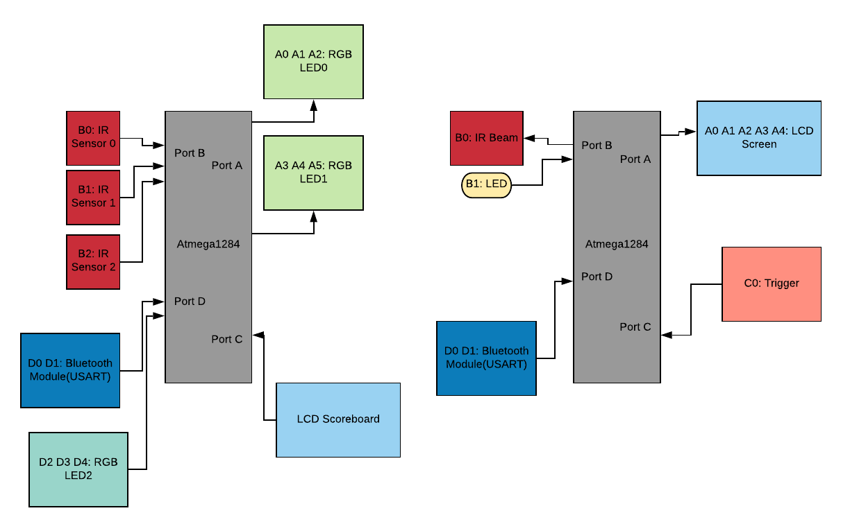](https://www.lucidchart.com/documents/edit/1c3dc23c-bb9f-45d1-a577-5c191682caf7/0?callback=close&name=docs&callback_type=back&v=793&s=612)

# Software

[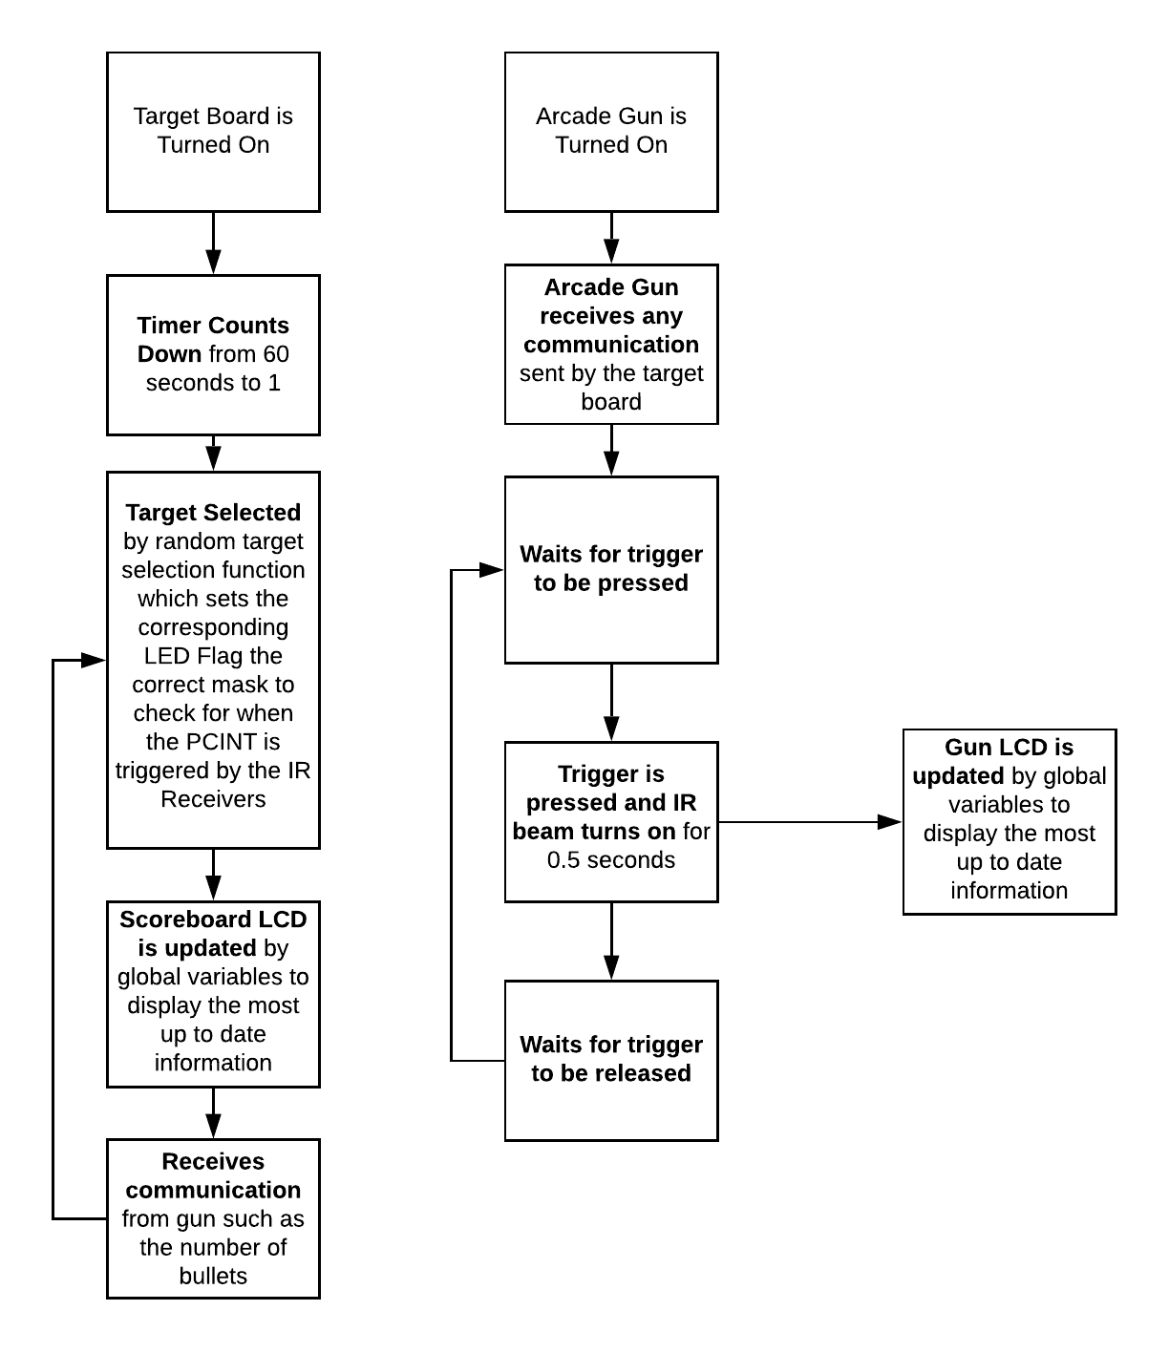](https://www.lucidchart.com/documents/edit/5f9ff36a-0b58-4968-b543-0aa058bbb821/0?callback=close&name=docs&callback_type=back&v=1342&s=612)

**Timer Countdown:** Handled by an SM that starts at 60 seconds and removes 1 from the global timer variable at a period of 1 second.

**Target Select:** Target is selected by a function which uses a random number generator modded with 2 to pick the target 0, 1, 2. The function also sets the target mask, and also turns on the proper LED light above the target. The targets are selected every 2 seconds.

**Scoreboard LCD:** LCD is updated by global variables such as time left, the score and the current number of bullets.

**Communication:** Communication from target is sent via USART, this SM is a last minute check just in case we have received any new data from the gun. The target also sends data to the arcade gun via USART such as when the game is over.

**Trigger Press:** SM detects when button is pressed, this turns the 5mm IR beam on for 0.5 seconds then it turns off.

**Trigger Release:** SM waits for trigger to be released before moving back to waiting for the trigger to be pressed.

**Gun LCD:** LCD is updated with the bullet count, it also displays that the game over when it receives the signal from the target board that the game is over.

# Implementation Reflection

I liked how the project turned out because it was a fun game that was built with hardware components instead of just playing through a screen. I think the games mechanics are also done really well as it is very responsive and fun to play as the LEDs change color and dance around as the targets move. Overall I think the end product was really good and the return bullets mechanic makes it more interesting and fun as opposed to having limited ammunition or maximum bullets.

The project was harder than I thought it was going to be as the bluetooth module would not connect to each other right out of the box. The setup for the two bluetooth modules to talk to each other was one of the most difficult things as I many tutorials were for the Arduino which came with a serial monitor. Other things that were difficult to implement was a custom communication protocol between the target and gun as it would not respond consistently during the beginning stages of my product.

Things that I would have done differently would be the arcade gun. While the gun is usable, it is more like remote. I would replace the button with a trigger mechanism of some sort whether it be custom made or taken from an already made arcade gun. Another option would have been to modify a current arcade gun but this would cause space issues as there would be no room for the screen, the ATMega 1284 , the bluetooth module and all the wires necessary to build the gun. For the target board, I wish I mounted the LCD screen on to the board, but I did not want to solder wires on to the LCD panel.

## Milestone

**Milestone I - 11/19/2019**

**In Milestone I, I will have the gun and target receiver working and built for one bullet. This part will require me to get the IR beam and receiver working, along with the scoring mechanics done. The part that will take me the longest will probably be making the target and gun and having them interact correctly.**

Milestone I was completed on time the day of the demo, I used this time to get familiar with my parts and how to use them. I also spent a portion of this time planning out my whole project and the SMs. After I completed the demo I had the gun shooting and the target responding as well as the timer counting down. I also had planned out the rest of my code at this stage.

**Milestone II - 11/27/2019**

**In Milestone II, I will be adding the return bullet mechanic and implement the bluetooth receiver on both the target and gun. This will allow them to communicate how many bullets are left in the game. I will also implement the main game mechanic where the targets will move and make the game more challenging.**

I had to submit Milestone II the next day, but the bluetooth module was still not working and I had bugs in my code involving me messing up the implementation of USART in parts of my code. These bugs would freeze my game and took me a while to debug. In this part, I had the score mechanic working, the bullet count, the target moving, and the USART working through two wires instead of bluetooth. The main reason why I was not able to finish this milestone on time was because I was trying to have the two bluetooth modules connect to each other at start up but a majority of tutorials online were for the Arduino which used the Arduino IDE’s serial monitor to program the bluetooth modules. I did not own an Arduino at the time so I had to figure out how the serial monitor worked and eventually got the bluetooth working on the final demo day. Once I figured that it was sending the commands via USART I tried to program those command on the ATMega 1284 to send the commands to program the bluetooth modules.

## Completed components

I completed my whole project which was an arcade shooter that had moving targets and a fun return bullets mechanic. The game is responsive and has no major bugs or consistent bugs that I noticed at the end when testing and playing the game. The targets correctly turned on and off when the targets were moving in time with the LEDs that indicated which target was on or off. The gun also properly turned off the target when the target was shot to prevent the player from shooting the target multiple times when it was on. The hardest part was the USART and getting the bluetooth modules to work together on start-up. After I was able to get this part to work the rest of my code worked and the arcade gun and the target were able to communicate with each other properly.

## Incomplete components

I was able to complete all components as my main struggle was with the bluetooth module, which I was able to get to work the day before the demo. Besides that I was able to get the all the other components such as the IR beam receiver and transmitter, the two LCDs and the multivariable LEDs to work properly.

# 

# Youtube Links

* Short video: <https://www.youtube.com/watch?v=plGuLYja2tA>
* Longer video: <https://www.youtube.com/watch?v=00q7O3aMa7g>

# Testing

Tests were all performed by myself if not specified. All tests were passed as I designed the tests to reach the Milestones and I had to complete all testing to complete my project.

**Arcade Gun: Passed**

* IR Beam:
  + Once triggered by button, beam stays on for only 0.5 seconds
  + Tested by having friend shoot target and held the button down
* Button:
  + On press IR beam turns on
  + Does not retrigger beam on release
  + Button does not respond when game is over
  + Tested by friend who shot target
* Bluetooth Module:
  + Pairs when device is turned on
  + USART Communication does not freeze
  + USART Communication sends correct commands
  + Devices reflect the USART message sent
* LCD Screen:
  + LCD responds quickly to the games situation
  + Updates when the bullet count changes

**Target Board: Passed**

* IR Receivers:
  + IR receivers correspond to LEDs
  + IR receiver only gives points if LED above it is on
  + IR receiver does not give points if the LED above it is not on
  + Tested by roommate who played the game
* LCD Screen:
  + LCD screen shows the countdown time and does not freeze
  + Game Over Screen is displayed when the player runs out of bullets or game time is over
* Bluetooth Module:
  + Pairs when device is turned on
  + USART Communication does not freeze
  + USART Communication sends correct commands
  + Devices reflect the USART message sent
* RGB LED:
  + LED turns off when target is hit
  + LED changes to special color for special target
  + LED changes to normal target color when targets are not special
  + LED for target is off when target is not on
  + Verified by roommate who played the game

# Known Bugs

One major known bug is that if you start the gun before the game, you can shoot out all the bullets before the game starts. I could have added a start button on the target board so the gun would wait on that start button. But I did not have time to add that and it was not one of my milestones so I did not attempt to complete it.

When you turn face the IR beam towards an IR receiver and then turn on the game it will give you two points. I am not entirely sure what is causing this. This bug is usually avoided if you do not start the game with the arcade gun facing the targets.

# Resume/Curriculum Vitae (CV) Blurb

**Homemade Arcade Shooter**

* Arcade shooter implemented with two ATMega 1284s
* Targets made from IR receivers and gun made with IR beam
* Target board and Arcade gun communicate via USART over bluetooth.

# Future work

The next feature to add would be extra game modes such as a speed trial or maybe multiple target are valid but only one gives max points. I would proceed by adding an extra function that I can use to select what happens at the “target select” stage of my SM. To design a case I would design a custom plastic case for both the target board and arcade gun which would also stylize the arcade gun more to look like a real gun instead of a remote control. Creating a custom PCB would reduce the size of my project greatly as I would be able to fit the PCB inside the target board instead of having it next to the target board like my breadboard.

# References

<https://howtomechatronics.com/tutorials/arduino/how-to-configure-pair-two-hc-05-bluetooth-module-master-slave-commands/>

<https://github.com/LittleBuster/avr-nokia5110>

<https://www.instructables.com/id/How-to-Configure-HC-05-Bluetooth-Module-As-Master-/>

# Appendix

Target Board:

[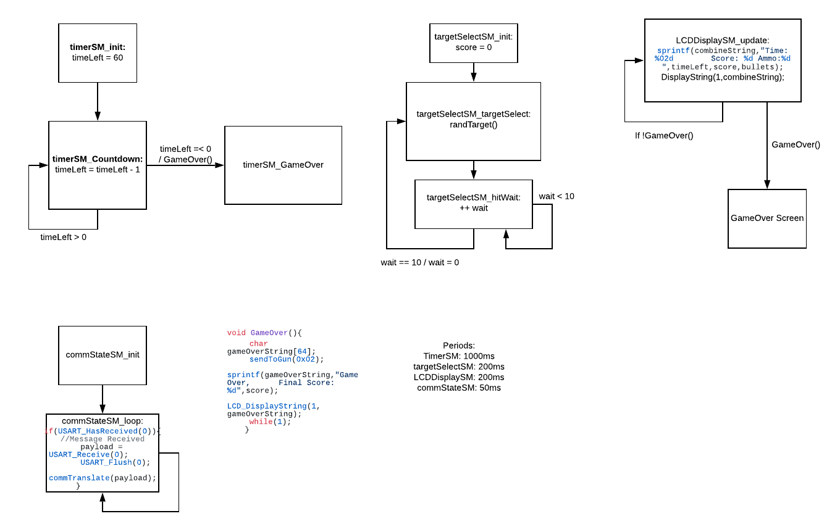](https://www.lucidchart.com/documents/edit/1a04c86f-cb13-41c3-a534-806d74e83955/0?callback=close&name=docs&callback_type=back&v=1269&s=680)

Arcade Gun:

[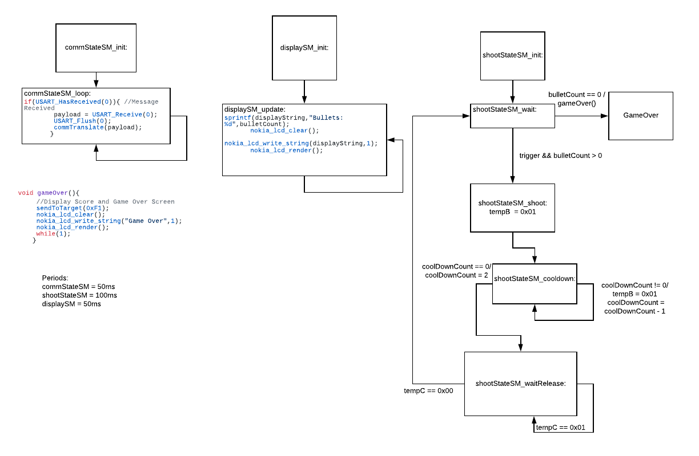](https://www.lucidchart.com/documents/edit/bc9681e5-28f9-40c8-9919-230c1dd39aeb/0?callback=close&name=docs&callback_type=back&v=1004&s=612)